Personal Development Plan (PDP)

Advising Seminar
A1PHR 25109

Submitted by

DEVAPRASAD M (1410725027)

In partial fulfilment for the award of the degree of

BACHELOR OF TECHNOLOGY
In
Electronics and Communication Engineering
Academic Year 2025-2026
Batch 2025-2029

Under the Supervision of
Dr ATUL
(ASSISTANT PROFESSOR)

ALLIANCE SCHOOL OF APPLIED ENGINEERING
ALLIANCE UNIVERSITY, BENGALURU
OCTOBER - 2025
Section 1: Self-Understanding
Title: Who Am I?
• SWOT Analysis Table:

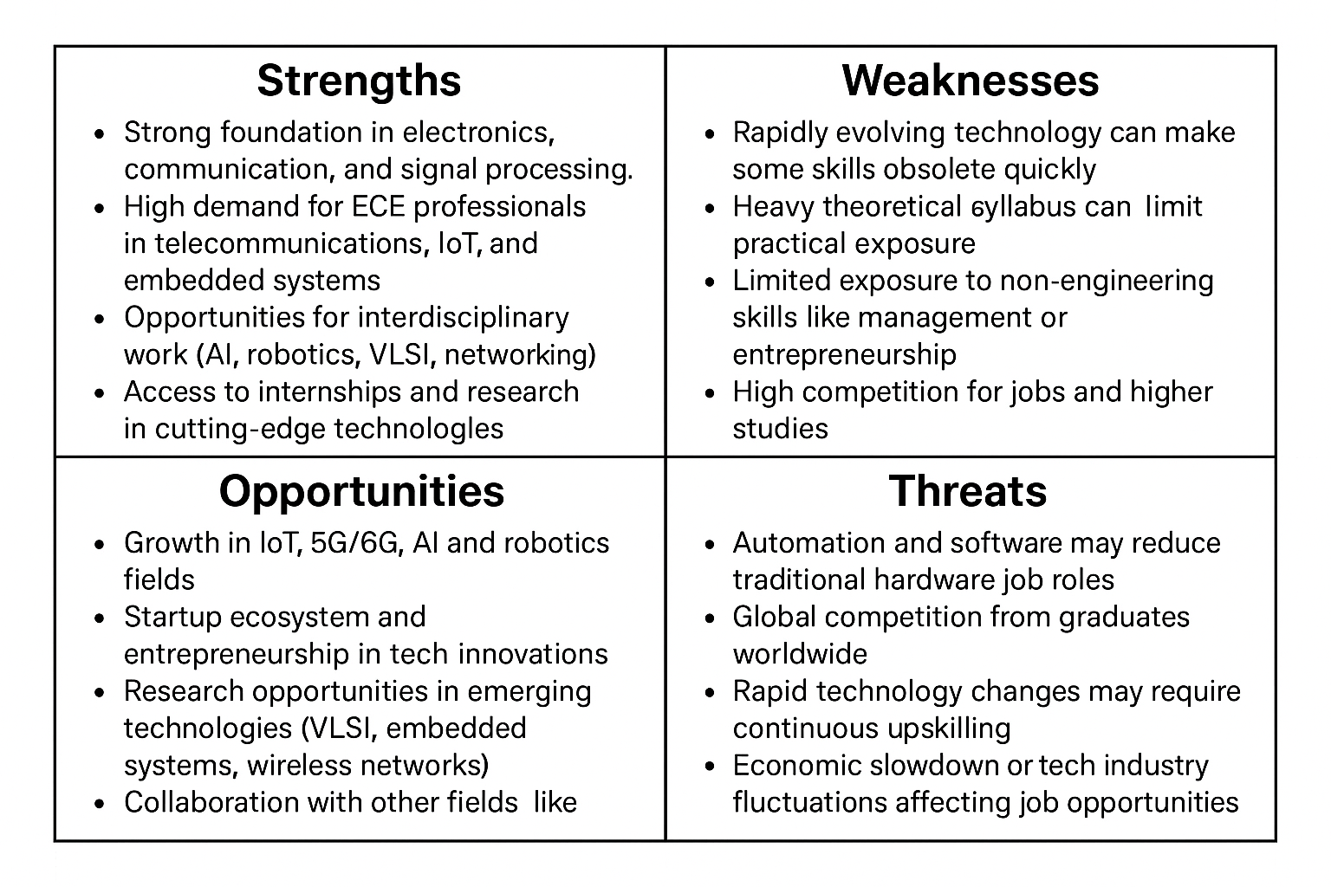

• Reflection Note :
A key insight from the SWOC analysis in ECE is the importance of adaptability in a fast-changing tech world. With technology evolving rapidly, continuous learning becomes essential to stay relevant. Focusing on interdisciplinary skills, internships, and real-world projects helps bridge theory and practice. This realization encourages a proactive approach to career growth through lifelong learning and research. Developing soft skills like communication, leadership, and entrepreneurship also becomes crucial. Overall, staying updated and versatile ensures long-term success and resilience in the ECE field.

Section 2: Goal Setting
Title: Where Am I Going?
Part A: SMART Goals
• Two Academic SMART Goals
- Improve semester GPA
- Enhance technical skills
• Two Personal/Professional SMART Goals
- Improve communication skills
- Build a professional portfolio
Part B: Goal Rationale & Timeline
1) Improve Semester GPA
A higher GPA reflects consistent effort and understanding of my core ECE subjects. It strengthens my academic profile for internships, placements, and higher studies.
Type: Short-term goal
Timeline: By the end of the current semester (around 4 months)
2) Enhance Technical Skills (Embedded Systems Course & Projects)
Gaining practical knowledge in embedded systems will help me apply theoretical concepts and increase my employability in core electronics fields.
Type: Short-term goal
Timeline: Complete within 3 months
3) Improve Communication Skill
Strong communication skills are essential for interviews, teamwork, and leadership roles. They help me express ideas clearly in both academic and professional environments.
Type: Long-term goal
Timeline: Noticeable improvement within 6 months, with continuous practice beyond that
4) Build a Professional Portfolio (LinkedIn Profile & Projects)
A well-organized portfolio helps showcase my abilities, connects me with industry professionals, and increases my visibility for job opportunities.
Type: Short-term goal
Timeline: Complete setup and networking within 2 months.
Section 3: Aligning Self and System
Title: Using University Resources Effectively
• Goal-to-Resource Mapping Table:
GOAL | UNIVERSITY RESOURCES | PLANNED ACTIONS | TIMELINE
Strengthen Academic Performance | Faculty Mentors, Academic Support Centre, Library | Attend mentoring and tutorial sessions regularly, use library materials for deeper learning, and participate in academic improvement workshops. | Aug–Nov(Current Semester)
Develop Coding & Technical Skills | School of Engineering Labs, Coding Club, Innovation & Research Cell | Join the coding club and hackathons, take part in coding bootcamps, and work on mini projects using lab facilities. | Aug–Nov
Enhance Communication & Leadership Skills | Language & Communication Centre, Student Clubs | Participate in group discussions, debates, and leadership activities through clubs and communication workshops. | Sep–Mar
Focus on Personal Growth & Well-being | Student Support Services, Counseling Cell | Join wellness programs, time-management and stress-relief workshops to maintain balance and focus. | Throughout the Year

• Planned Follow-up Actions (at least 2):
1. Maintain a learning log/ Reflection Journel to record experiences and skills gained from each activity.
2. Share achievements and certificates with the Career Advancement & Networking (CAN) Cell for inclusion in the professional portfolio.
Sep-Nov
Section 4: Co-curricular & Extracurricular Engagement
Title: Learning Beyond the Classroom
• Engagement Plan Table:

Activity / Opportunity | Relevance to Goals | Mode | Timeline
 | Supports higher studies and enhances technical skills for ECE career growth. | Online | Sep–Nov
  NPTEL / Online Certification (Embedded Systems / IoT)
 | Applies classroom concepts practically; helps achieve technical skill and teamwork goals. | On-campus (Club-based) | Aug–Dec
  Electronics & Robotics Club Participation
 | Improves presentation and interpersonal skills needed for professional growth. | In-person (Language & Communication Centre) | Sep–Mar
  Communication & Soft Skills Workshop
 | Provides industry exposure relevant to ECE domains like 5G and VLSI. |  | Sep–Nov
  Guest Lectures / Technical Seminars
  Hybrid (On-campus / Online)

Section 5: Reflection & Revisions
Title: Looking Inward: What Changed?
• Reflective Journal Entry :
Key Reflections:
Through this course, I have learned to understand myself better as both a student and a future engineer. realized that setting clear and realistic goals keeps me focused and motivated. The SMART goal framework taught me how to plan effectively and measure my progress instead of working without direction. I also discovered that I learn best through practical, hands-on experiences rather than just theory.
My perspective on my goals has changed as well. Earlier, I aimed mainly for good grades, but now I value skill development, communication, and real-world exposure equally. I've learned that success in the electronics and communication field requires both technical ability and soft skills like teamwork and confidence.
This course encouraged me to participate more in workshops, clubs, and online certifications that support my long-term professional growth. I now see my goals as part of an ongoing process of learning and self-improvement rather than fixed achievements

Section 6: Final Submission & Presentation Summary
Title: My Personal Development Portfolio
o Key goals :
Study regularly and attend extra classes to get better marks, Take online courses in electronics and complete small projects.
o Planned resources and activities :
Use library, ask help from teachers, and join study groups, Work in ECE labs and do practice projects.
o Career alignment :
Good grades help in placements and higher studies,Technical skills help in getting jobs like Embedded Engineer or IoT Developer.

